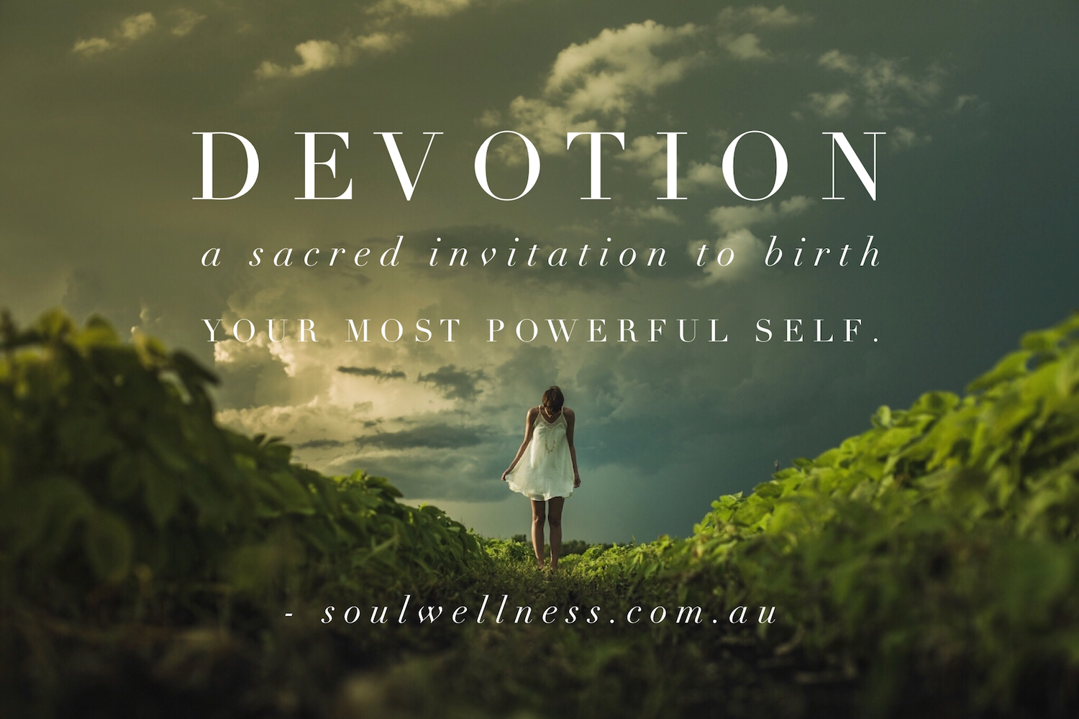

DEVOTION INITIATION JOURNEY APPLICATION
_____________________________________________________________________
Full Name:
Contact phone number:
Contact email address:
Age/Date of birth:
_____________________________________________________________________

Hello beautiful heart,

Thank you for taking the time to apply for the Devotion Initiation Journey.

I know that your journey of Devotion will be a magnificent ride, and it’s one that I am honoured to guide you along.

Please know that the answers you provide are respectfully confidential, and will not be re-produced or distributed.

The best way to complete the application is to write freely and honestly.

There are no specific answers I’m looking for. My sole intention is to get to know you, where you’re at, right now.

Ready to begin?

Q1. Why are you drawn to the Devotion Initiation Journey?

Q2. What has been happening in your life over the past 12-6 months?

Q3. What do you constantly crave or seek external to yourself that you never, or rarely, seem to find?

Q4. What do you dream of creating for yourself during your Devotion journey?

Q5. What support do you need to grow?

Q6. Have you participated in healing (of any description) before? If so, let me know below.

Thank you for your honest answers, and for the time you’ve taken to complete your application.

Please save this document with your full name at the very beginning, and then send it directly to me via email: melissa@soulwellness.com.au.

I look forward to receiving it, and will reply as soon as possible (most likely within 24 hours).

Once you’ve pressed ‘send’ on your email application, take a moment to celebrate yourself for taking this courageous step in the direction of your devotion journey.

Consider doing something beautiful and nourishing for yourself.

Close your eyes and breathe into your heart: how will you celebrate yourself in this moment?

Much love and soul wellness,
Melissa xx
